Thanks Charles.

Good observations.

Yes, clearly RA is not a “me too” product. They do have some good features.

With my limited version of Windows I couldn’t add new comments, but I could add to yours so I have done that in a few cases, highlighted in yellow. I have added a few bits to the text, also with a yellow highlight, then added a section at the end

**“Report Authority” – the document authoring and global XBRL compliance solution for the finance function**

**14th June 2012**

[*Report Authority*](http://www.reportauthority.com/) *– is a new document authoring and global XBRL tagging solution for the finance function being officially* [***launched this month in London***](http://events.r20.constantcontact.com/register/event?llr=gi9uarcab&oeidk=a07e5pxmql5863e4c25&oseq=a0119fkzzbjnq)*.  Gary Simon, FSN’s managing editor takes a look at the product which was developed by AMOSCA, an award winning Enterprise Performance Management (EPM) consultancy specialising in the provision of Oracle Hyperion solutions.*

**INTRODUCTION**

XBRL has been in existence since 1998.  Initially it was conceived as a way of digitally tagging financial data in a consistent way, so that financial results prepared according to a common accounting standard such as IFRS could be readily compared.  But the SEC’s (Securities and Exchange Commission’s) decision in 2004 to encourage the voluntary electronic filing of EDGAR submissions using XBRL was a turning point which highlighted the value of XBRL to regulators.  Since then XBRL has been enthusiastically embraced by regulators around the globe, anxious to streamline and codify their data collection in a bid to simplify and improve regulatory supervision.

But the transition to ‘electronic filing’ of say, 10-K’s and 10-Q’s or the filing of CT600 tax return data to HMRC in the UK has not always been a smooth one. Finance functions around the world have found XBRL difficult to understand and first generation software tools too limited in capability.  As a result, many resorted to outsourcing the ‘tagging problem’ to their auditors, printers and other third parties.  This proved to be error prone and costly with the finance function losing both visibility and control over the process.

Others turned to ‘simple’ conversion tools to tag accounts prepared in Microsoft Word or Excel only to find that they are, limited in functionality and extraordinarily time-consuming to use, making them impractical on a group-wide level involving many sets of accounts. It was this unsatisfactory background which encouraged the founders of AMOSCA, a leading EPM Consulting organisation deeply steeped in Hyperion applications to question the established approaches.  After re-visiting the problem they developed a completely fresh approach and a new product, called [“Report Authority”.](http://www.reportauthority.com/)

Report Authority has been designed from the outset to allow accountants to take ownership of XBRL document generation in-house by shielding them from the complexity of XBRL syntax and allowing them to swiftly generate XBRL tagged accounts and filings to comply with regulators exact requirements. It has also been designed to be cost effectively deployed throughout a group of companies and most importantly to provide the ability to roll-over and maintain statutory filings in future years with the minimum of fuss.

This has been achieved by a radical re-think of the way that organizations approach the task of generating XBRL compliant documents, principally to view the work required as a complete document authoring process rather than a more limited tagging exercise, or afterthought that frequently gives rise to error.

Report Authority achieves this in six distinct phases.

**DOCUMENT AUTHORING**

Report Authority, enables an accountant without any prior knowledge of XBRL to create a fully valid and compliant set of accounts or other regulatory filing from scratch or from an existing Report Authority template.  The user interface is immediately familiar to any user of Microsoft Word.  At its core, Report Authority is packaged with all of the frequently used global taxonomies (such as IFRS, UK GAAP, GRI, COREP and FINREP).

**Fig 1 Report Authority is packaged with the most common global taxonomies grouped by the authorities that have mandated their use.**

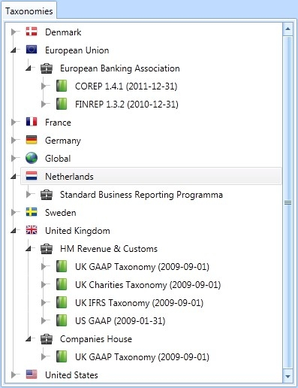

The deceptively simple set-up involves adding information such as entity name, the accounting period, the default currency and monetary scale, but behind the scenes the user is unwittingly driving the generation of the basic XBRL and the way that tags will be deployed.

Having selected the taxonomy and jurisdiction under which the document is prepared the user navigates to the relevant part of the taxonomy (presented as a tree structure in the left hand pane) and drags the relevant account lines into a skeletal document which already ‘knows’ based on the initial user choices what kind of layout is required, for example, columns with ‘current year actuals’ and ‘prior year comparatives’.  Natively, Report Authority has a considerable amount of ‘financial intelligence’ built it, with added support for detecting and eliminating rounding differences and incorrect signage. This alone helps to eliminate commonly found errors in preparing XBRL documents.

**Fig 2 Document set up in Report Authority is deceptively simple. Line items in the taxonomy are simply dragged onto the document to create fully tagged content**

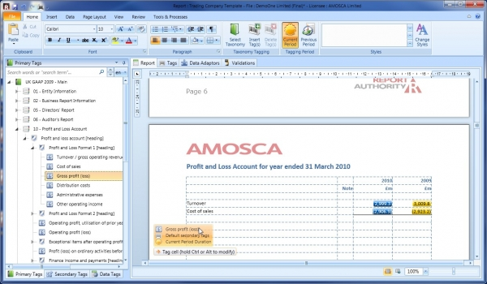P: (07) 4099 5414P: (07) 4099 5414

Automatic note numbering with referencing and the ability to insert fully formatted and headered financial tables means that it is very easy and quick to create consistent structured accounts.

The near simultaneous creation of a document with the underlying XBRL tags helps to safeguard the integrity of the statutory filings generated in Report Authority, i.e. that the human readable document completely and accurately reflects the underlying XBRL.  This is distinctly different from first generation XBRL conversion/tagging tools which work in the reverse direction i.e. accounts rendered in Word or Excel are tagged ‘after the event’ against taxonomies.  This is more time consuming and error prone because of mismatches between descriptions of line items in the accounts which may be out of kilter with the underlying taxonomy descriptions.

**AUTOMATION**

Following the above procedure the document is ready to accept values. Report Authority can work with a variety of data sources including Microsoft Excel, and by extension, any system capable of exporting to Excel and Hyperion HFM.  In the case of the former, data is brought in by direct cell reference, named ranges or look-up tables (which enable a responsive connection to data in query refreshes) within the worksheet.  However, in the case of Oracle Hyperion HFM (HFM), the whole multi-dimensional structure of the HFM application is exposed within the Report Authority application.

**Fig 3 Hyperion HFM Dimensions are exposed directly in Report Authority**

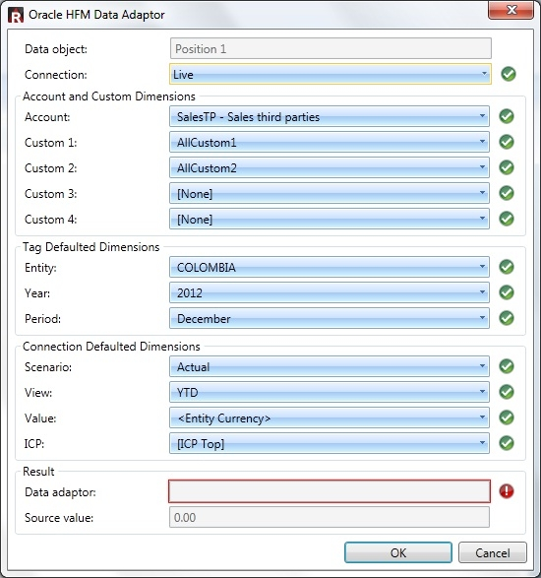

Of the 12 HFM dimensions [djh: Curious. Always 12? Always these 12? Reads like that.], it is usually only the Account and Custom dimensions which need to be altered.  All other dimensions are defaulted to either the connection defaults, or to the document variables such as Entity, Year and Period.

This means that any data in HFM can be quickly dragged into the document under preparation. A simple set of dialogue boxes allow monetary scale and signage between the source data and Report Authority to be brought into line.

**Fig 4 A set of dialogue boxes allow monetary scale and signage between the source data and Report Authority to be brought into line.**

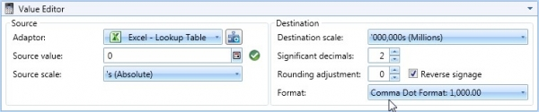

**VALIDATION**

Validation in Report Authority is also profoundly different from many other tools offered in the market in that in Report Authority, there is no such thing as an invalid tag.  [djh: Our concept of validation is far broader than this, encompassing accounting sense/rules which the taxonomy does not enforce. Our tags will always be valid but that is to be expected. It is a given. What is much harder is ensuring entity and FS wide data integrity. How can RA handle that without the structure of Bros and logic?] Facts are validated at the point of tagging, such as checking that the fact is a valid date, and once tagged, the tag’s integrity is maintained through the use of (in this case) a calendar control. [djh That is the easy bit!]

***Fig 5:  Tagged facts cannot be invalid eliminating much of the review effort of competing tools.***

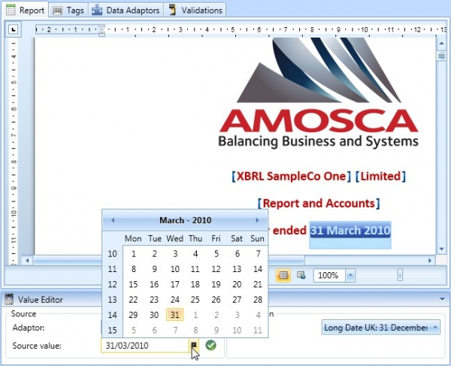

Furthermore, a report can be validated against more than one authority.  For example, in the UK, Companies House and HMRC have slightly different rules.  A report which may be accepted by HMRC could be rejected by Companies House.   By selecting which set of rules to apply when generating an XBRL instance document, the user can ensure that any document fully complies before the accounts or CT600 tax returns are submitted – saving enormous time for users and helping them to avoid delays and penalties for incorrect submissions.

**Fig 6 When generating an XBRL instance document, the user can select which regulator validations to use to ensure acceptance.**

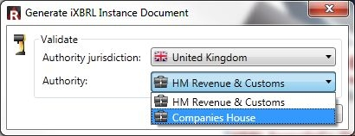

**REPLICATION**

An important feature of Report Authority is the ability to replicate instantly a template document to be used by multiple entities across the organisation.  Templates created in this way retain all of the structure, metadata and logic of the originating document and therefore a group can, if desired, ensure the consistent application of regulatory reports across the enterprise. An administrator can simply toggle through the different entities by changing the reporting entity description and/or date.

**RE-USE**

‘Roll-forward’ is a specific function in Report Authority which, as the name implies, takes the contents of a document and repositions it in the following period (usually a year), moving current year values into the comparatives column, updating the XBRL tags and at the same time re-populating the current year links previously established with an underlying spreadsheet or consolidation system like HFM.

**MAINTENANCE**

The template approach makes Report Authority very amenable to changes in reporting requirements or, say, accounting policy.  A simple change effected in the master template ripples all the way through to all of the related (linked) reports providing group finance with the assurance that all changes are completely and accurately reflected across the group.

**SUMMARY**

Report Authority is differently positioned in the market from many so called ‘tagging tools’.  Designed by accountants rather than IT experts [djh: garbage. Any good modern product needs both] it encourages a process driven approach to generating XBRL filings which ensures end-to-end control commencing with selecting the right taxonomy and regulatory jurisdiction for the document through to ensuring that XBRL documents faithfully reflect valid XBRL and comply with each regulators unique submission rules.

The system’s ease of use coupled with the ability to replicate the documents in an instant enables changes to be made ‘on the fly’ and the ability to rollover documents from one year to another in a similar way to accounting systems saves time and money.  But above all, Report Authority empowers organisations to maintain the XBRL process in house, avoiding the expense of engaging expensive consultants or using other third party providers.

# OUR THOUGHTS

## Key features

* Multiple taxonomies - Immediate global reach and attraction for global entities reporting under multiple taxonomies.
* Validation against more than one authority [djh Syntactic validation but not sense validation = of some use but less than it sounds]

Furthermore, a report can be validated against more than one authority.  For example, in the UK, Companies House and HMRC have slightly different rules.  A report which may be accepted by HMRC could be rejected by Companies House.

* Review Report – tagging accuracy and queries

Generate review reports which include not only all the information a reviewer would need to signoff on the completeness and accuracy of tagging and adherence to the authority’s business rules, but also focussing on the risk areas such as negative value tags, context definitions report scales.

* High degree of automation and set up – Replication, Re-use and Maintenance.
* Links to underlying data and schedules – increased speed and accuracy. [djh: Possible source of errors rather. Might be ok in a well controlled big entity environment but still has many issues. Just plain bad for the accounting practice environment = total lack of control again and lots of potential for stuff ups]

## Target Market:

* Direct use by large complex corporates with multiple entities. Yes
* Use by accounting practices on their clients. Do not think so) No

Really comes in to its own if the Entity uses Hyperion HFM. Yes, though can work with just Word & Excel.

Is it of use to SMEs? Does **not** look to be targeted to them at all.

## How much does it cost?

Pricing model?

It is noticeable that they give no indication what so ever. In fact they never ever even talk in terms of cost savings versus other methodologies or product types. Do give 30 day free evaluation of fully functional product.

How is it supplied / delivered?

* Cloud? [djh: No. It is a desk top product. Could be supplied via web of course but it is not a cloud system.]

No indication. But notice following at the top of their request an evaluation page

Report Authority is available on a free 30 day no obligation basis for evaluation purposes. To request a demonstration and evaluation of our software, please fill in the form below.

Implies a person visits you; show you the software, installs it and then keeps asking how you are getting on with the evaluation.

Thinks we can take it that this will not be a low cost program. (If really only aiming at very largest corporations there is no incentive for them to have low underlying costs). True.

## What is it?

Clearly this at least a very smart tagging tool. It also goes beyond just being a tagging tool. Yes.

### Is it an Accounts Production program?

Originally an AP system virtually duplicated the clients’ nominal ledger.

Later it became very much summarised accounting information e.g. TB, with huge amount of schedule information.

BUT

Whatever level of detail and however input, all this information was stored within the data structure of the AP program.

RA does not look to do this. It merely holds a skeleton - albeit with the nice touch of live links! [djh: Not nice to me. Import and store, yes, but not hot linked as I think that is dangerous for a statutory reporting system. The Automation – Data adaptors and Connections area of RA (as shown on the Features & Screenshots page) are powerful, but perhaps too much for the product purpose and a case of IT “featureitis” rather than “Designed by Accountants” I suggest]

This latter feature further indicates that no accounting per se goes on with in the program e.g. adjusting journals.

So how well does this sit with the external auditors/accountants and their own working paper systems?

[djh: And how does it fit with their claim of “ Natively, Report Authority has a considerable amount of ‘financial intelligence’ built it, with added support for detecting and eliminating rounding differences and incorrect signage. “ As I said in my addition to your comment re this “To do this properly they would need to build up the underlying ledger. Do they?”]

The live link feature could even undermine the Auditors position to say what set of data they were working with. (Appreciate that almost certainly this feature can be turned off)

Does it matter if it is not an Accounts Production program?

More pertinently, does it render the AP program obsolete, at least for larger entities? [djh: But larger entities were not likely to be using an AP system anyway, surely?]

It looks as though they would define it as a new class of program; a Report Authoring Tool, as well as a tagging tool. From their FAQs

**Is Report Authority an XBRL conversion tool or an accounts production tool?** Both. Report Authority can import existing accounts in Word or Excel format for conversion into XBRL format, or can be used as the report authoring tool and replace Word or Excel entirely.

Note also highlighted section of response their FAQ

Should we expect a steep learning curve when first using Report Authority to create reports?

No. Report Authority will be instantly recognisable and intuitive because the word processing functionality such as report styles, ribbons, tables, contextual menus and keyboard shortcuts have been designed to closely resemble Microsoft Word. **This word processing functionality has however been expanded over what is found in MS Word** **in areas where the accounts production process would obviously benefit.** Additionally, XBRL technical concepts have been removed from the workflow wherever possible to improve the user experience.

## Key difference from BRAIINs

### What reports and schedules can it create and How?

RA still looks to be time consuming to set up. Set a report line by line. But if aimed for very large Corporates, the costs of this time would still be insignificant. But this cost would assume significance when applied to much smaller entities.

Wonder how it copes with complex reports like Cash-flows. Assume it just picks data from a ready created CF, lays it out in its grid style and then matches the taxonomy element. i.e. think it requires such a report to have already been created; what it adds is XBRL tagging and some refinement in presentation.

So the Entity or the Accounting Practice stills needs to have created the schedule or report.

(Accept that for very large entities this is unlikely to be an issue)

[djh Yes to all that.]

### Accounting Posting Logic

Related to the above is the handling of the more complex reporting requirements such as Restated figures.

This applies to seeing related transactions in the round to ensure that they are logical and complete.

In that area may also fall handling Financial Instruments; and their movements.

Suspect what is does not do is provide such a coherent data structure as we are doing; so will not be able to tie together the integrity of the underlying accounting structure (even though it may well do for many of the XBRL elements). [djh: Indeed.]

(NB re BRAIINS – it is not necessary for it to be able to handle individual journals, other than maybe adjustments. It is only necessary that it can “see” the journals in some grouped fashion, with sufficient separation to ensure incorrect off-sets do not occur. This is largely reflected by the structure of BROs. BROs do not have to mimic the full CoA of an the Entity, merely contain a sufficiently detailed structure so that it can both output to the financial statements and build an overall flow of summarised transactions. So mapping either from another AP program or even directly from an entity’s general ledger does not have to be one to one.)

## Djh Comments

What this does highlight to me is how we need to be clear about our target market.

Undoubtedly as per your recent work on FI and our ability to validate the accounting data, we could handle many things better for large complex entities than RA or any other system.

However, we would not be as sexy as RA with its multiple live links and Word like editing etc, and I feel we would have a hard job selling into the big entity market. We just don’t have the resources to market in that area, nor to develop the differentiating features to allow us to charge £10,000 or whatever in that market, versus the £25 to £100 per entity via the cloud system.

Braiins reflects our joint backgrounds of thinking “accounting practice” and the resulting need for control = no on the face of the account editing, no live data links, but full data and accounting integrity, with audit trail of changes by whom when.

I know that recently given our ability to handle complex things like FIs well, you have been enticed by the large entity market and thoughts like “revenue from that 1% greater than from the other 99%”. But how real is it really?

My view is that we don’t have a chance in the big entity market versus TR etc who are going after it, plus RA, however well our product might compare.

Whereas we do have a chance in the accountancy practice market. Our “integrity of the underlying accounting structure” is big for that market, once we get the point through to people, whereas big entity Fin Cons won’t think they need it. They will just dismiss the little cloud based codgers anyway.

So, I think the main lesson from looking at RA is “Focus Braiins sharply on the accounting practice with mostly SME clients as our target market.”

Agree?

D 11.07.12